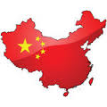
Name:___________________________
Date: ____________________
Hour: ________ Mrs. Golfin’s World History
Ancient China
Webquest

Click the link below to take a virtual tour along the Great Wall of China! Scroll down to the large moving picture of the Great wall and click the arrows to move forward along the Great Wall.
Great Wall of China Virtual Tour
Whew! That was a lot of walking wasn’t it? I’m sure it was a really cool experience! What did you see and what was it like walking along the Great Wall?

____________________________________________________________________________________________________________________________________________________________________________________
__________________________________________________________________________________________

Once you and your partner have finished the touring the Great Wall, scroll down on the same page and look over the variety of tours offered. Select one tour you would be most interested in. Write the name of the tour AND a brief description of the tour below. China Tours
TOUR NAME: ________________________________
Briefly describe your tour: ____________________________________________________________________
__________________________________________________________________________________________
__________________________________________________________________________________________
Follow the links below to find missing clues hidden in the interactive maps! Click the yellow arrows at the top right of each map to navigate to the next page. Click on the maps, picture icons, and map key to find the clues!
Interactive Map 1
The Great Wall of China is made of _________________, _______________, & ________________. In some places the wall is _______ feet high and _______ feet wide.
Horses were a symbol of ______________ and _______________ to the Chinese.
Interactive Map 2
China covers over ___________ million square miles, making it the _____________ largest country in the world.
Currency Converter
Use the currency converter to compare the current China and U. S. exchange rate on money.
How many Chinese Yuan’s (CNY) are equivalent to 1 U.S. dollar? _______ Yuan’s = ________ U.S. dollar.
What does this tell you about the value of China’s money?
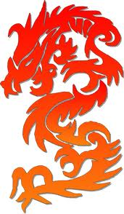
_____________________________________________________________________________
Visit the link below, scroll down and watch the short video clip “Ch’in Dynasty” and list THREE accomplishments or expansions that were made during the Ch’in (Qin) Dynasty.
VIDEO: Ch'in Dynasty
- ______________________________________________________________________
- ______________________________________________________________________
- ______________________________________________________________________
Follow this link to explore ancient Chinese artwork: Ancient Chinese Artwork

Describe a piece of art from the Shang period. ___________________________________________________
________________________________________________________________________________________
Describe a piece of art from the Tang period. ___________________________________________________
________________________________________________________________________________________
Ancient Stories: Follow the link and choose ONE of the following ancient stories to read. Answer the corresponding questions.
Ancient Stories
- Nian, the Horrible Monster:
According to Chinese culture, what does the color red signify? ___________________________________
What do the Chinese use to help to drive away any lingering evil spirits from the old year?
______________________________________________________________________________________

- The True Story of Milan: *Click (Word Version)*
According to the “True Story of Milan,” what is the ultimate inspiration and message of the story?
_______________________________________________________________________________________
_______________________________________________________________________________________

Calligraphy & Chinese Symbols
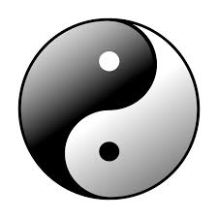
Discover the meanings of just a few of China’s calligraphic writing symbols. Choose two symbols to draw and tell what each symbol means. Chines Symbols

Meaning: Meaning:

Wondering what traveling along the Silk Road was like? Follow the link to hear the “Sounds of the Silk Road.”
You can…Play Music…Make Your Own Music…and Explore Instruments!!! Have Fun!
Sounds of the Silk Road

What are two instruments you might hear while traveling along the Silk Road?

- _____________________________ 2. _______________________________

CONGRATULATIONS! YOU HAVE SUCCESSFULLY COMPLETED THE ANCIENT CHINA WEBQUEST!

