Directions:
Your mission, if you decide to accept it, is to complete as many of the items below as you can from the information on the British Musem's Mesopotamian site.
Click HERE to view the webpage about "Time".  1. Read the 4 paragraphs that give an overview of Mesopotamian settlement.  2. Find the following words and click on them: "tells," "excavate"  3. Write the definition of each word on your worksheet. | 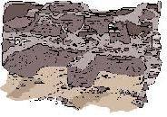
Click HERE to view the webpage that contains "Mesopotamian Time Lines".
1. Select one of the timeline topics from the down arrow menu that says, "Choose a time line".
2. Explore the timeline you have chosen & list at least two facts that you learn from the timeline.
KEEP GOING, YOU'RE DOING GREAT!
Click HERE to view the story of the re-discovery of Mesopotamian cultures.  Read the story carefully, screen by screen, by pressing the arrow at the bottom right to move to the next screens. Be sure to click on the "more" buttons which appear on many screens allowing you to read the "pop-up" windows. Close pop-ups & continue pressing arrows to read the entire story.  Answer the following questions.  1a. Who was the "father of cuneiform"?  1b. Explain how he deciphered some of the cuneiform carvings.  .  2a. Why do you think archeologists were unable to work in Iraq after the 1991 Gulf War?  2b. What option(s) are available to archeologists who specialize in the ancient ruins of the Middle East after the Gulf War stopped their access to the Tigris/Euphrates valley? | 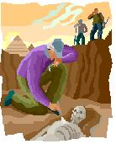
CONGRATULATIONS, MISSION ACCOMPLISHED!

